Weather API Practice

Kelvin Mutua Kilonzo

Park University

CIS 606 Applied Data Mining Analysis of Big Data

August 30th, 2022

Class Instructor: Amelia Mapples

Weather API Practice

Introduction

API stands for Application Programming Interface. They enable 2 software components to communicate with each other using a set number of protocols (AWS, 2022). To accomplish this task several tools were selected. They include Openweather.com servers for API, Jupiter notebook, citify module, date time module, matplot module, pandas module among others.

Steps and guidelines

All the data can easily be accessed through this [GitHub link](https://github.com/kmk2020/CoinCap_Crypto). The API key is stored in the config.py file while all the workings are shown in the city_weather_api.ipynb file.

Steps

The following steps were followed,

1. Import dependencies and create an endpoint url to test the working of the API calls with a sample city in this case Kansas.

Figure : Test URL with Kansas city

The code returned a response of 200 meaning it’s working correctly.

1. Create a list of fields that you would like to query in an API call for Kansas City weather. In this case, the following were selected as fields of interest. Coordinates, Max Temp among other fields were returned successfully .

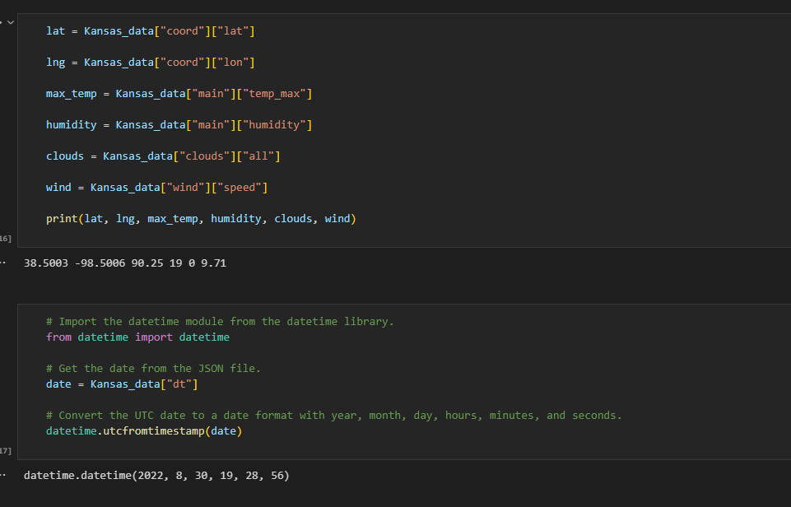

Figure : Data query for Kansas City

1. Generate random cities from the NumPy library and install citypy module to generate cities based on randomly selected cities. A list of cities through a for loop the reason for adding counters is create a delay since the open weather website place a limit to the number of calls you can make withing certain durations of time.

1. Create a dataframe for the cities and only select the first 20 and save them into data frame ..repeat the process to produce a second csv

Figure :save to the second csv file

1. Load both csv files and perform calculations, merge, and plot graphs and save images.

Figure :Load both csv

Figure : Merge csv 1 and csv2, list column names

Figure : join temp_change _df with final_complete_cities_df

1. Plot charts and save images

Figure : line graph, and a bar graph showing Citys against their temp change

Images

Conclusion

There was a temperature change in all the cities within the two different times the API was queried.

# References

AWS. (2022). *What is an API?* Retrieved from https://aws.amazon.com: https://aws.amazon.com/what-is/api/

https://openweathermap.org/